Submissions close on Friday 23 February 2024

Write your own submission or use this one as a basis, though we strongly recommend rewriting this in your own words – it will have much more impact.
To read more and to have your say by making a submission, visit the NSW Government’s page on its website:

Explanation of Intended Effect: Changes to create low and mid-rise housing

** February 2024
NSW Department of Planning
To whom it may concern

Dear Sir/Madam,

RE: Response to the proposed NSW Government state environmental planning proposal (SEPP) for mid and low rise residential flat building and dual occupancies

Georges River Council (GRC) was formed in 2016 with the amalgamation of Hurstville and Kogarah Councils.
The local area is unique for its size, i.e. 38.36 square kilometres in that it has two major heavy railway lines, the T4 (Eastern Suburbs & Illawarra Line) and T8 (Airport & South Line) running through its area with 11 railway stations. It is bounded on its western side and part of the southern boundary by the Georges River.
The proposed SEPP to create low and mid-rise housing around major transport hubs and commercial centres throughout NSW should not be a one glove fits all approach. With 11 railway stations and nine major local centres, this proposed SEPP will impact a major percentage of GRC’s R2 zone.
The map below depicts where low rise terrace houses and two-storey apartment buildings and up to sic (6) storeys (with the opportunity for eight storeys if affordable housing is provided) mid-rise Residential Flat Buildings may be built under this SEPP.
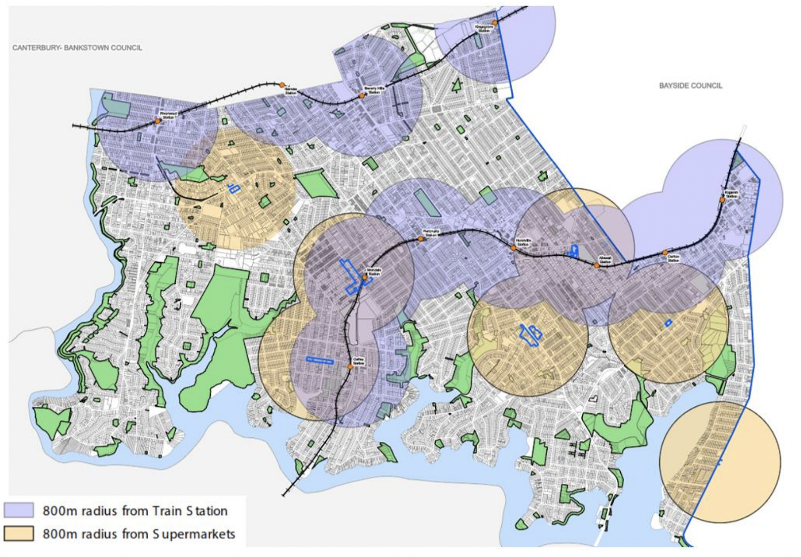
The areas of the map that aren’t highlighted can have dual occupancies as long as the allotment is 450 square metres in area.
It is quite obvious from this map that the whole of the LGA will be impacted by this SEPP.
According to GRC’s Planning Dept this SEPP will provide capacity at a minimum for up to 150,000 additional dwellings within the GRC LGA, which is approximately half of the NSW State Government’s target of delivering 314,000 new dwellings by 2029 across all of NSW.
Some of the consequences of this SEPP in the GRC residential suburbs are:
- It will change in such a detrimental way the streetscape character of all residential areas in the whole LGA;
B. With very small narrow sites (as the SEPP suggests 12 metre frontages) it reduces the ability to create architecturally pleasing front facades leaving bland and monotonous streetscapes, particularly for dual occupancies;
C. This SEPP changes the concept of the traditional backyard of family homes where it reduces its size thus reducing the tree coverage, landscaping, wildlife habitat with the built environment replacing the natural environment;
D. Having small lot sizes and street frontages, kerbside car parking will severely impact the local streets. This is now prevalent in many streets where medium to high density development has occurred. This SEPP is supposed to encourage people to use public transport but it is only human nature to have the need for their own transport because we live in a vast city and an even greater country where a vehicle is required to conveniently get from one place to another. Car parking and vehicle usage will become an overbearing negative factor to the intention of this SEPP.
Although I understand the need to increase housing supply so as to put downward pressure on housing affordability and rents, I believe this SEPP is totally unacceptable for the GRC Local Government Area (LGA). As stated previously it will completely change the entire face of the LGA.
There are a number of other issues where I feel this SEPP is inappropriate; there are many kilometres of environmentally sensitive foreshores in the GRC LGA which will be affected, essentially by run-off into the waterways. This SEPP also allows dwellings to be built on very small allotments, which will reduce the native vegetation and habitats, therefore adversely impacting threatened species of the area. It will reduce the dominance of landscape over built form and will increase the amount of cut and fill construction on the foreshores, all impacting the quality of the Georges River and the natural environment.
Council at its meeting held on 25 February 2019 adopted the Greater Sydney Region Plans target for tree canopy cover of 40% by 2038. The proposed SEPP will seriously impact GRC from achieving this target.
This SEPP has made no provision to provide for more green space for the community’s recreation. An issue that was most prominent during the Covid-19 pandemic.
Much of GRC LGA’s infrastructure is already overstretched. For example, since the introduction of the 2015 Kogarah City Plan, Kogarah Primary School is at 150% capacity and the Kogarah North Precinct, where the school is located, is estimated to be at less than 40% developed. The sewer infrastructure is also running at capacity in many areas with sewer overflows regularly occurring at Lime Kiln Bay, Poulton Park, Myles Dunphy Reserve and Yarra Reserve, Oatley and in the stormwater channels through Beverley Park as indicated by signs warning of this prevalence. The public transport system is already stretched to its limits and the roads are also at saturation point throughout most of the LGA.
GRC LGA has three (3) Heritage Conservation areas all within walking distance of either Penshurst, Hurstville or Kogarah railway stations. To allow residential flat buildings, manor houses, dual occupancies, etc. in these areas will completely destroy the heritage significance of these three areas.
Since 2016 GRC has been at the forefront of increasing its housing numbers by rezonings and expanding its commercial centres to provide additional capacity and create jobs for its increasing population.
Since the amalgamation, GRC has spent tens of millions of ratepayers’ money on providing appropriate studies to guide development so as to cater for the future needs of its residents including the increase to its population over the next 20 years.

These studies which have been implemented with Community consultation and input include:
- The GRC Local Strategic Planning Statement (LSPS)
This sets out the 20-year vision for land use in the Council area, the shared community values that are to be maintained and enhanced, how population growth and change will be managed into the future and the special characteristics which contribute to the local identity of the LGA.
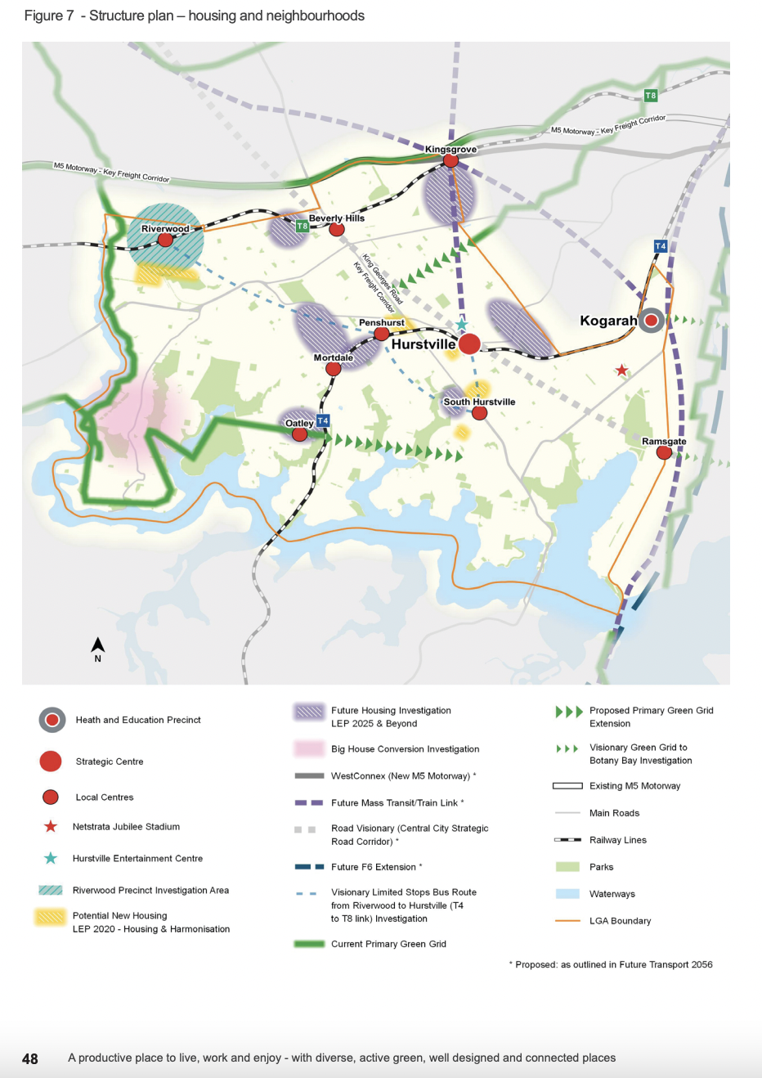
See Figure 7 from GRC Local Strategic Planning Statement (LSPS)

- The GRC Local Housing Strategy, 2020
This sets out the strategic direction for housing in the LGA over the next 20 years.
This strategy identifies housing demand, gaps and issues and establishes housing objectives to manage future growth and sets links with GRC’s vision for housing, which aligns with the directions, objectives and action for housing in the South District.
The Greater Sydney Commission forecast a population increase of an additional 30,000 people for the GRC LGA from 2016 to 2036.
Based on these figures an additional 14,000 new dwellings are required to be created by 2036.
That target has already been reached by GRC, 12 years ahead of schedule.
Even though these targets have been met GRC is still actively pursuing additional housing investigative areas for up-zoning opportunities for additional housing.
- Inclusive Housing Strategy & Delivery Programme
GRC is at the forefront of Local Government when it comes to inclusive housing.
In 2021 the GRC adopted the above strategy which outlines Council’s position and approach to provide additional housing in the LGA with a target of between 5% and 10% of new dwellings as affordable housing by 2040.
- Georges River Commercial Centres Strategy & Commercial Centres Economic Study
In 2020 GRC undertook a number of studies relating to its 48 business centres, which include 2 Strategic Centres (Hurstville and Kogarah), nine Local Centres mainly around the railway stations and Small Villages and Neighbourhood Centres.
The purpose of these studies was to examine all the centres as a whole and to harmonise land uses and to encourage employment and expansion of some of these centres to cater for emerging population increases and to create job prospects for its residents.
- Foreshore Scenic Character Study
As stated previously, GRC is bounded on its western side and part of the southern boundary by the Georges River.
This environmentally sensitive area commences at Salt Pan Creek in the north west of the LGA and finishes in the south east at Captain Cook Bridge.
The study carried out in 2021 clarified the types of local character present in the entire foreshore area.
This study was a technical and evidence-based document and GRC is still formulating and reviewing local planning measures due to the sensitive environmental characteristics along the entire foreshore area.
CONCLUSION
It can be concluded from the above studies that have been completed over the past number of years, that the GRC’s planning Department has put GRC in a strong position to continue its path of increasing its housing supply through its planning framework in accordance with its Local Strategic Planning Statement.
GRC has actively pursued its Housing Strategy And Commercial Centres Strategy.
Fourteen thousand (14,000) additional new homes can now be built under its current LEP and two major local centres namely Mortdale Shopping Centre and the Beverly Hills Shopping Centre have Master Plans already approved which allows both expansion of both centres for both shop-top housing and mid to low rise residential flat buildings in surrounding suburbs.
GRC continues to systematically review its planning instruments to meet the expected increase in its population over the next decade in accordance with its Local Strategic Planning Statement.
Besides the two Strategic Centres of Hurstville and Kogarah, there are still seven Local Centres where Council has the capacity through its Master Plan mechanism and in line with its LSPS to consider and implement additional housing. Council’s Planning officers are also focusing on additional housing investigative areas to up-zone for higher densities.
For all of the above reasons the Department of Planning and Environment is requested to defer the GRC from this proposed SEPP for two years to allow GRC to continue pursuing its own Housing and Commercial Centres Strategies, which will also give GRC the opportunity to review its Local Strategic Planning Statement to create for additional and diverse housing in the two Strategic Commercial Centres and the remaining seven Local Centres in the LGA.
For all the above reasons the Department of Planning is requested to:
· to more accurately map the application of the policy to enable the community at large to understand the implications of the new changes, to enable an informed community consultation and response;
· acknowledge the extensive planning initiatives already undertaken by GRC to achieve housing targets in a logical and structured manner that respond to local character and amenity, infrastructure capacity and so on; and
· defer the GRC from this proposed SEPP for two years to allow GRC to continue pursuing its own Housing and Commercial Centres Strategies, which will also give GRC the opportunity to review its Local Strategic Planning Statement to create for additional and diverse housing in the two Strategic Commercial Centres and the remaining 7 Local Centres in the LGA, in order to minimise the poor urban design and amenity outcomes, particularly in lower density neighbourhoods, that will arise from the proposed SEPP.
We await your response.

Yours faithfully,
<< Insert your name and surname>>
<< Insert your suburb>>

