We strongly recommend writing this in your own words to ensure the greatest impact on Council’s officers.

<insert date>
Georges River Council
Via email: mail@georgesriver.nsw.gov.au

To Whom It May Concern
Dear Sir/Madam,

RE: DA2023/0487: ST GEORGE MOTOR BOAT CLUB 2 WELLINGTON STREET, SANS SOUCI

I wish to lodge a strong objection to the proposed expansion of the St George Motor Boat Club as shown in documentation accompanying DA2023/0487.
In particular, I am concerned regarding the expansion of the Marina, the two-level carpark and the ground floor terrace extension and the new rooftop terrace/bar area. These matters will be discussed in more detail further in this submission.
I appreciate that the St George Motor Boat Club (Club) plays an important role in the economic and cultural activities in the Sans Souci peninsula and will continue to do so well into the future.
EXISTING USE RIGHTS
We are told the Club itself enjoys ‘existing use rights’ under the Environmental Planning and Assessment Act, whether this is the case or not, the Club is surrounded by low density residential dwellings.
We understand that existing use rights for this property were created with the adoption of the County of Cumberland planning scheme 1951. This was established for the surroundings of Kogarah Bay in the court case Kyriacou v Kogarah MC (1995), of which Council no doubt has records as it was found negligent of its understanding of existing use rights at the time.
Existing use rights provide for the continuation of previous rights to operate the same use on the parcel of land, but in general where the change of use involves only minor alterations and additions and does not increase the existing floor space by more than 10% or involve the enlargement, expansion or rebuilding of the premises from what existed at the time the rights were created. If this interpretation is correct, we would be interested to learn from Council how existing use rights can be used to validate the proposed major expansion works.
Any alterations and additions to the Club and Marina should be modest and sympathetic to all residential dwellings in the neighbourhood and be mindful to the safe boating in Kogarah Bay. This submission will show that this DA is not in the public interest, will have a detrimental impact on the neighbourhood and the waterways of Kogarah Bay and should be refused.
TWO-STOREY CARPARK – CORNER OF PLIMSOLL STREET AND WELLINGTON STREET
The proposed plans to replace the 65 space at-grade car parking area on the corner of Plimsoll Street and Wellington Street and create in its place a two-level car parking area for 134 spaces, an additional 69 spaces, will have a dramatic adverse impact on the surrounding residential area and views from the public domain.
The carpark will also be provided with a solid 1.4 metre high acoustic barrier wall around the perimeter of the first floor level, which will further exacerbate the visual impact of this structure when viewed from the public domains of both Plimsoll Street and Wellington Street.
See below excerpts from the ‘View Loss Statement’ from the Applicant’s Planning Consultants GYDE in ‘View 18’ of their report, which indicates that view loss from the public domain at the corner of Plimsoll Street and Wellington Street is considered high to medium, however, the Consultants argue that it is not significant enough to alter the plans, indicated by their comment under the column ‘Selected for Further Analysis’ ‘NO’.'
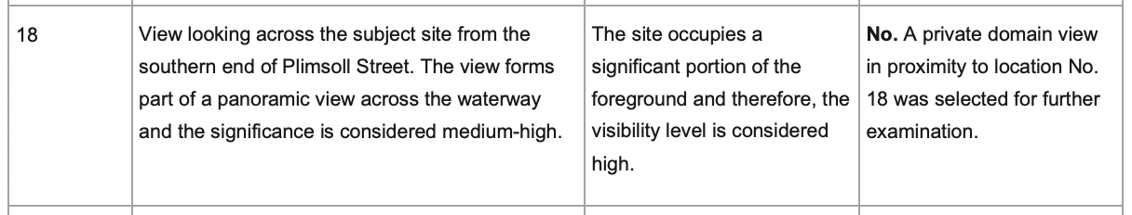
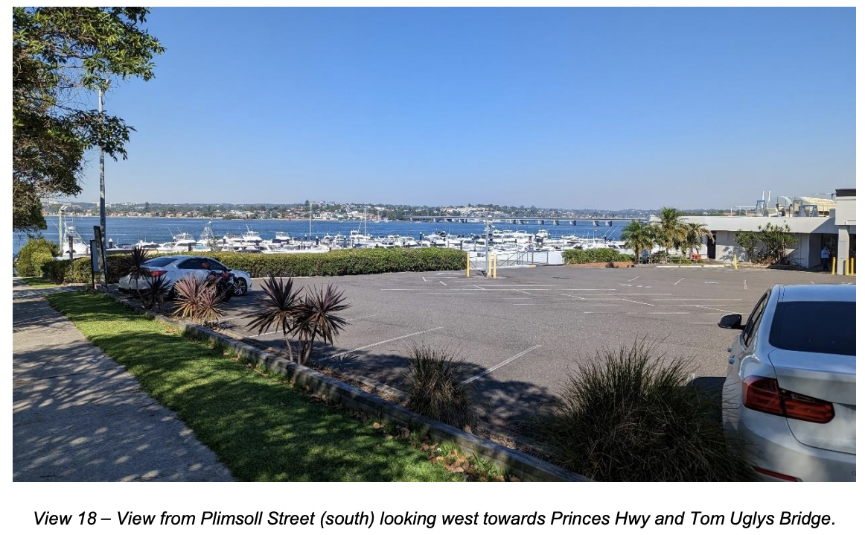
It is my opinion that the height and scale of this two-level carpark with its 1.4 metres high acoustic barrier wall is considered visually intrusive. It obscures vistas across the existing carpark to the Georges River, which includes significant historical land markers.
The proposed two-level car park will result in a loss of public amenity and does not serve to protect the natural environment, nor that which has been developed and which also represents historical significance in its contribution to the surroundings, such as Tom Uglys Bridge.
EXTENSION TO THE MARINA
The proposal to extend and increase the Marina from 229 berths to 314 berths, an increase of 85 berths, will have a major impact on the waterways of Kogarah Bay.
The Marina at the northern end adjoining Anderson Park proposes to be extended out into Kogarah Bay by 94 metres for Berthing Arm A, while Berthing Arms B, C and D will extend out into Kogarah Bay by 74 metres, 60 metres and 22.8 metres respectively.
The impact on navigation in Kogarah Bay will be quite severe. The width of clear waterway 1.7 metres in depth will be reduced from the current 153 metres to 68 metres, which in my opinion will adversely impact on the navigation of vessels into and out of Kogarah Bay.
Another concern is the visual impact and loss of scenic views in respect to the 94-metre extension to berthing Arm A from Anderson Park.
The extension to Berthing Arm A that adjoins Anderson Park more than doubles the length of this part of the Marina. The visual impact of this extension has not been fully shown in the DA documentation and, as mentioned previously in respect to the two-level carpark obscuring vistas across the Georges River, this Marina extension will obscure vistas across Kogarah Bay resulting in a loss of public amenity to the area, particularly from Anderson Park.
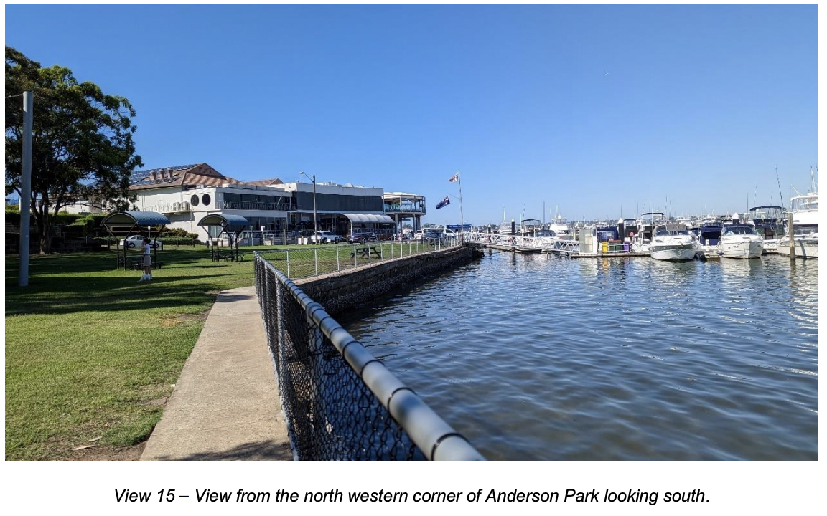
Above is the consultants' photograph of the view looking south from Anderson Park to the Marina but they provide no photograph from the same spot looking west beyond the Marina to show the impact of an extension of the Marina a further 94 metres out into Kogarah Bay. They also do not display photographic evidence to show the impact that the Marina extension has from the public domain of Anderson Park, Wellington and Vista Streets.
The photographs below illustrate the Marina at present and also how the proposed extension of Berthing Arm extensions will impact the visual panorama.
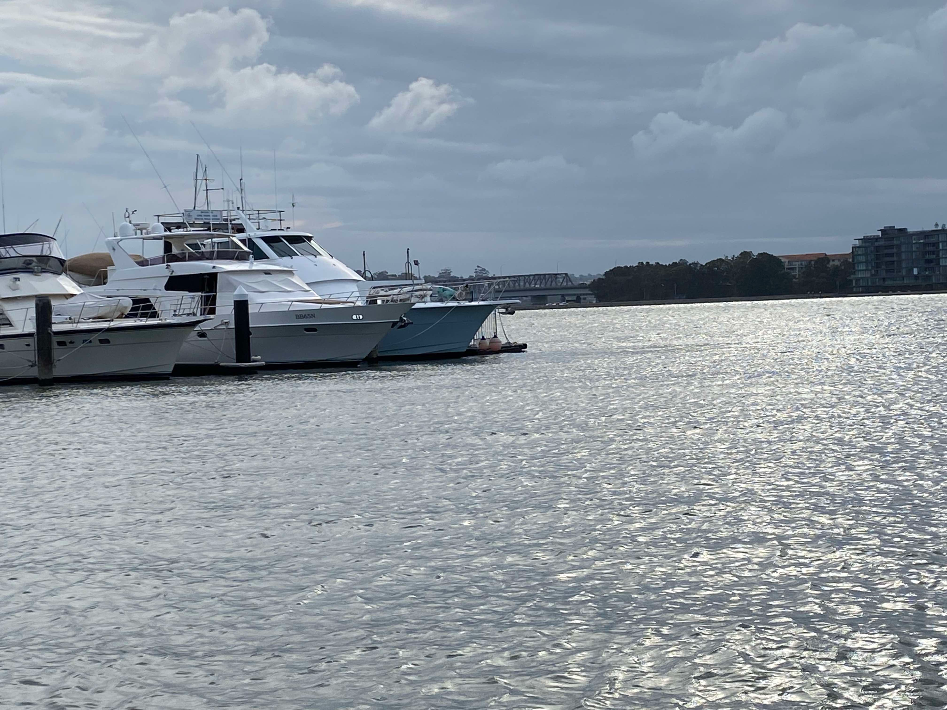 | 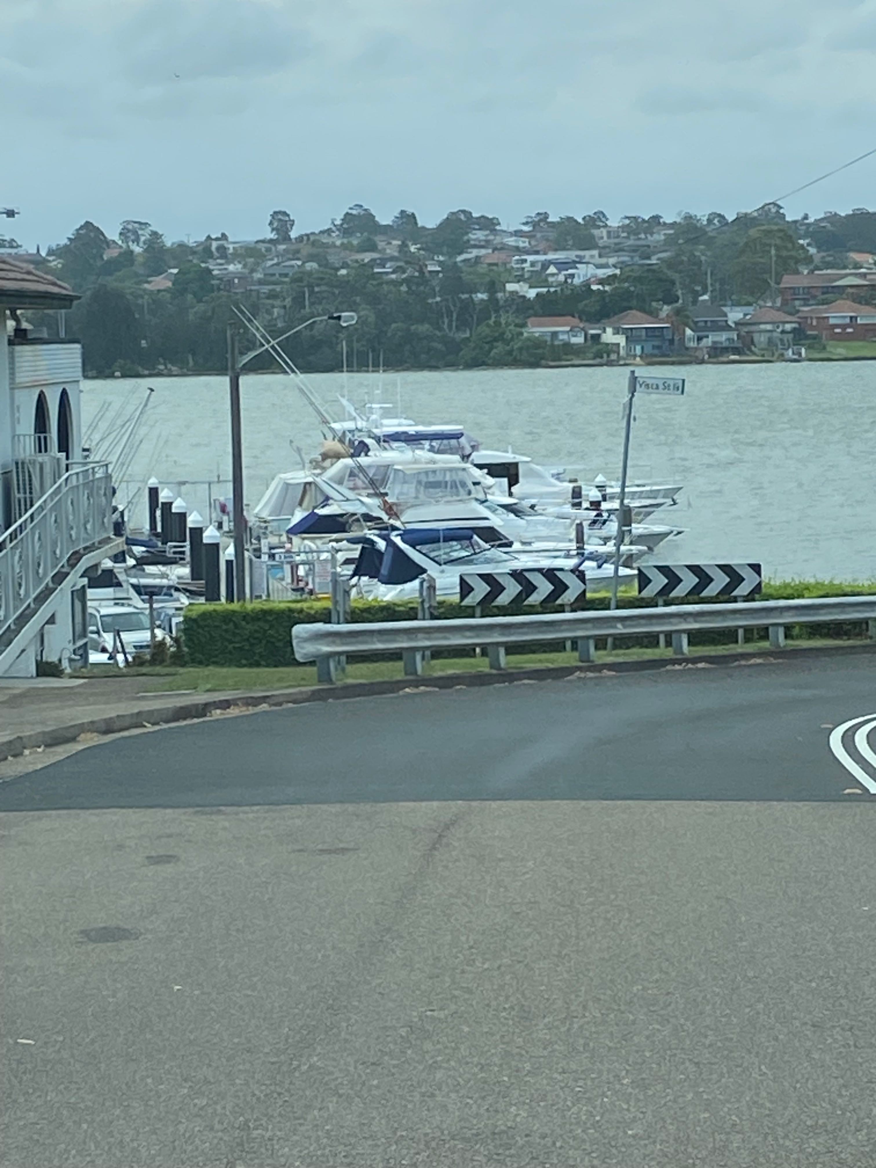 | 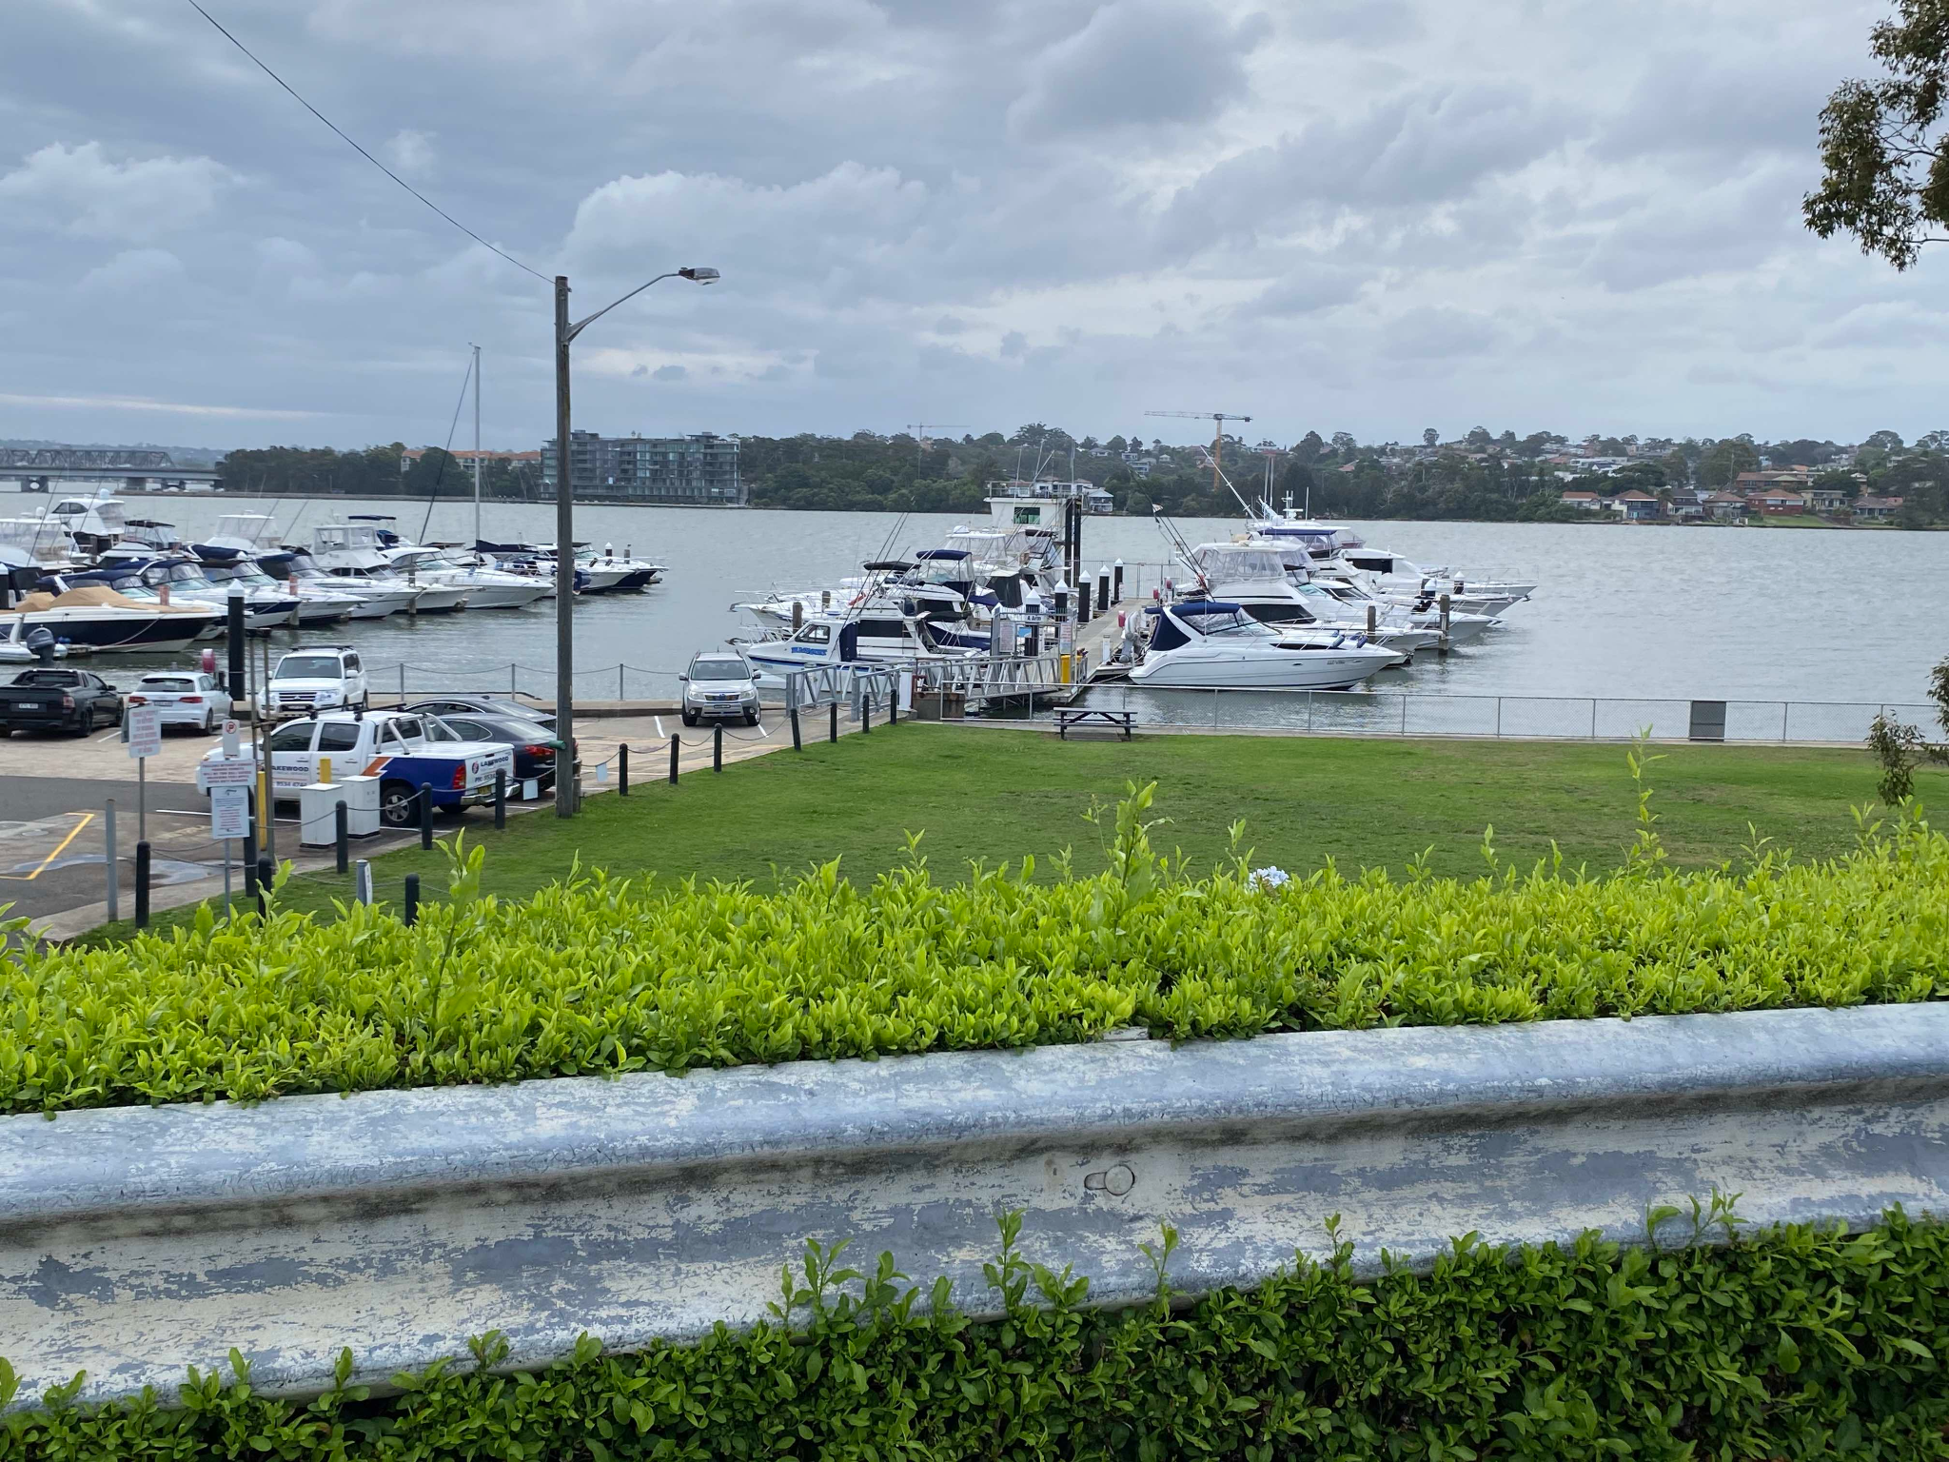
Looking from Anderson Park to the end of the current Marina Arm showing how the vista across Kogarah Bay will be obscured. | View from the public domain of Wellington Street shows the length of the current arm of the Marina. | View from the public domain of Vista Street showing 2 of the arms intended for extension.
ENVIRONMENTAL CONCERNS TO MARINA EXTENSION
Due to the large increase in the number of berthing bays and boating activity, there is a greater risk of oil, petrol and effluent spills into the local waterways of Kogarah Bay and the Georges River.
I am also concerned that there could be the possible loss of sea grasses in Kogarah Bay due to the large footprint expansion to the marina, which may impact marine life in the area.
A factor that has not been considered is the impact the extended and enlarged marina mooring area will have on wave attenuation in the Bay. Wave energy is an important contributor to cleansing the Bay during storm periods, and is essential more than ever given the accumulation of fine silt where the storm water channels enter the Bay at Carss Park and Claydon Reserve.
GROUND FLOOR TERRACE EXTENSION AND THE ROOFTOP TERRACE/BAR
Our final objection to this proposal is the extension of the ground floor terrace and the new rooftop terrace/bar above the St Kilda Room and terrace.
Our main concern with both terraces is the noise impact it will have on the adjoining residential neighbourhood, particularly from the new rooftop terrace/bar area.
To have up to 68 patrons in the evening with live music on this open roof-top terrace up to midnight on Friday and Saturday nights up to 10.30pm Monday - Thursday nights and 9.30pm on Sunday night will have a detrimental impact in respect to acoustic noise on the amenity of the adjoining residential neighbourhood and to the wider residential community.

CONCLUSION
In conclusion, I am happy for the Club to have a modern facelift but to impose an ugly two-storey carpark with a 1.4 metre high solid wall around the perimeter of the 1st floor level on the corner of Plimsoll Street and Wellington Street, to extend the Marina into Kogarah Bay by up to 94 metres reducing the navigational waterway from 153 metres to 68 metres and the possible environmental degradation it may cause to the waterways of Kogarah Bay and its foreshores all add up to a development that is not in the public interest and will severely impact on the amenity of the surrounding residential area and the safe boating of vessels in Kogarah Bay. Adding an open rooftop terrace/bar for up to 68 patrons with live music late into the evenings on most nights of the week, leaves little doubt that this DA should be refused.

Yours sincerely,

<insert your name and contact details>

